Static Routing & VLSM Subnetting Lab
Base Network: 192.168.5.0/24 | Cisco Packet Tracer | Cisco 2911 Routers

Lab Topology
The topology consists of two Cisco 2911 routers (R1 and R2) connected via a point-to-point link on G0/0/0. Each router services two LANs through 2960-24TT switches.

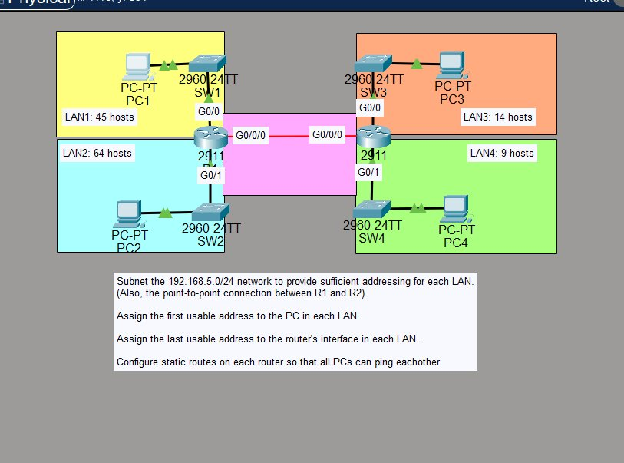
Figure 1 – VLSM Lab Topology (Cisco Packet Tracer)
Section 1 – Subnet Allocation
Subnets are allocated from largest to smallest host requirement using VLSM. This avoids wasting address space by fitting each subnet tightly to its actual need.

Subnet / LAN | Network Address | First Usable | Last Usable | Broadcast | Usable
LAN2 (64 hosts) | 192.168.5.0/25 | 192.168.5.1 | 192.168.5.126 | 192.168.5.127 | 126
LAN1 (45 hosts) | 192.168.5.128/26 | 192.168.5.129 | 192.168.5.190 | 192.168.5.191 | 62
LAN3 (14 hosts) | 192.168.5.192/28 | 192.168.5.193 | 192.168.5.206 | 192.168.5.207 | 14
LAN4 (9 hosts) | 192.168.5.208/28 | 192.168.5.209 | 192.168.5.222 | 192.168.5.223 | 14
P2P (R1↔R2) | 192.168.5.224/30 | 192.168.5.225 | 192.168.5.226 | 192.168.5.227 | 2

Section 2 – Router Interface Addressing
The last usable address in each LAN subnet is assigned to the router interface (gateway). For the P2P /30 link, R1 gets the first usable (.225) and R2 gets the second usable (.226).

Interface | IP / Mask | Role | Assignment Rule | Notes
R1 G0/0 | 192.168.5.190/26 | LAN1 Gateway | Last usable | To SW1
R1 G0/1 | 192.168.5.126/25 | LAN2 Gateway | Last usable | To SW2
R1 G0/0/0 | 192.168.5.225/30 | P2P R1 side | First usable | To R2
R2 G0/0 | 192.168.5.206/28 | LAN3 Gateway | Last usable | To SW3
R2 G0/1 | 192.168.5.222/28 | LAN4 Gateway | Last usable | To SW4
R2 G0/0/0 | 192.168.5.226/30 | P2P R2 side | Second usable | To R1

Section 3 – PC Addressing
The first usable address in each subnet is assigned to the PC. The default gateway points to the router interface (last usable) in the same subnet.

PC | LAN | IP / Mask | Default Gateway | Assignment Rule
PC1 | LAN1 | 192.168.5.129/26 | 192.168.5.190 | First usable
PC2 | LAN2 | 192.168.5.1/25 | 192.168.5.126 | First usable
PC3 | LAN3 | 192.168.5.193/28 | 192.168.5.206 | First usable
PC4 | LAN4 | 192.168.5.209/28 | 192.168.5.222 | First usable

Section 4 – Router Configurations
R1 – Interface Configuration
R1> enable
R1# configure terminal

R1(config)# interface GigabitEthernet0/0
R1(config-if)# ip address 192.168.5.190 255.255.255.192
R1(config-if)# no shutdown
R1(config-if)# exit

R1(config)# interface GigabitEthernet0/1
R1(config-if)# ip address 192.168.5.126 255.255.255.128
R1(config-if)# no shutdown
R1(config-if)# exit

R1(config)# interface GigabitEthernet0/0/0
R1(config-if)# ip address 192.168.5.225 255.255.255.252
R1(config-if)# no shutdown ! Critical – must be up for static routes to appear
R1(config-if)# exit

R1 – Static Routes
! Route to LAN3 (192.168.5.192/28) via R2
R1(config)# ip route 192.168.5.192 255.255.255.240 192.168.5.226

! Route to LAN4 (192.168.5.208/28) via R2
R1(config)# ip route 192.168.5.208 255.255.255.240 192.168.5.226

R1(config)# end
R1# write memory

R2 – Interface Configuration
R2> enable
R2# configure terminal

R2(config)# interface GigabitEthernet0/0
R2(config-if)# ip address 192.168.5.206 255.255.255.240
R2(config-if)# no shutdown
R2(config-if)# exit

R2(config)# interface GigabitEthernet0/1
R2(config-if)# ip address 192.168.5.222 255.255.255.240
R2(config-if)# no shutdown
R2(config-if)# exit

R2(config)# interface GigabitEthernet0/0/0
R2(config-if)# ip address 192.168.5.226 255.255.255.252
R2(config-if)# no shutdown ! Critical – must be up for static routes to appear
R2(config-if)# exit

R2 – Static Routes
! Route to LAN1 (192.168.5.128/26) via R1
R2(config)# ip route 192.168.5.128 255.255.255.192 192.168.5.225

! Route to LAN2 (192.168.5.0/25) via R1
R2(config)# ip route 192.168.5.0 255.255.255.128 192.168.5.225

R2(config)# end
R2# write memory

Section 5 – Troubleshooting Encountered
Problem | Root Cause | Fix Applied
Static routes not appearing in 'show ip route' on R1 and R2 | GigabitEthernet0/0/0 (P2P link) was in shutdown state on both routers. IOS only installs a static route if the next-hop is reachable via an active interface. | Entered 'no shutdown' on G0/0/0 for both R1 and R2. Routes immediately appeared in the routing table.

Key lesson: Always verify all interfaces are up with 'show ip interface brief' before troubleshooting routing issues. A static route pointing to an unreachable next-hop will not be installed in the routing table.

Verification Commands Used
! Check interface states (look for 'up' in Status and Protocol columns)
R1# show ip interface brief
R2# show ip interface brief

! Verify static routes are installed (look for 'S' prefix)
R1# show ip route
R2# show ip route

! Confirm connectivity end-to-end
PC1> ping 192.168.5.209 ! PC1 pinging PC4

Section 6 – Connectivity Verification
After fixing the G0/0/0 shutdown issue on both routers, full connectivity was confirmed. The first ping attempt showed 50% loss (ARP resolution in progress). The second attempt showed 0% loss, confirming all static routes are working correctly.

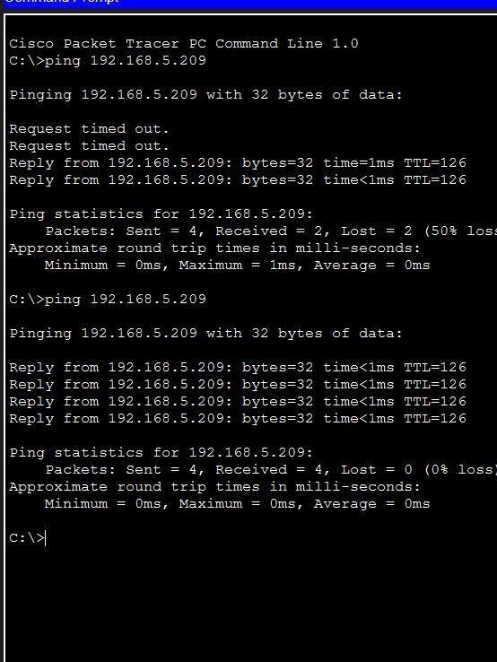
Figure 2 – PC1 successfully pinging PC4 (192.168.5.209) with 0% packet loss
Section 7 – Key Concepts
VLSM (Variable Length Subnet Masking): Allocating different-sized subnets from a single address block based on actual host requirements. Subnets are sized from largest to smallest to avoid fragmentation of the address space.

Static Routing: Manually configured routes telling each router the next-hop address to reach remote networks. R1 must have routes for R2's LANs and vice versa. Both directions must be configured or traffic will be one-way only (black-holed return traffic).

Interface State & Route Installation: IOS will not install a static route into the routing table if the exit interface or next-hop is unreachable. Always bring interfaces up with 'no shutdown' before expecting routes to appear.

